Here is the information for the webinar for Adobe Connect and the information if they want for the conference call is below.

Once they connect a they will get a popup with 4 choices to connect the audio.

If they choose by phone the conference call is below.

They can click on the link below and sign in as a **guest.**

<http://iowadeptoftransport.adobeconnect.com/utilities/>

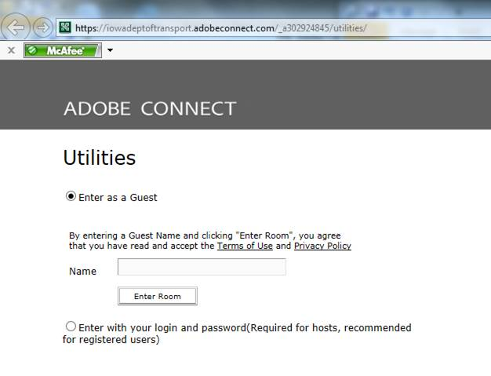

Conference call information:

Toll-free dial-in number (U.S. and Canada):

(866) 685-1580

Conference code:

5613718387