Incomplete Task Summary Report

Home then Menu, select Enterprise Reports, it then populates the following reports

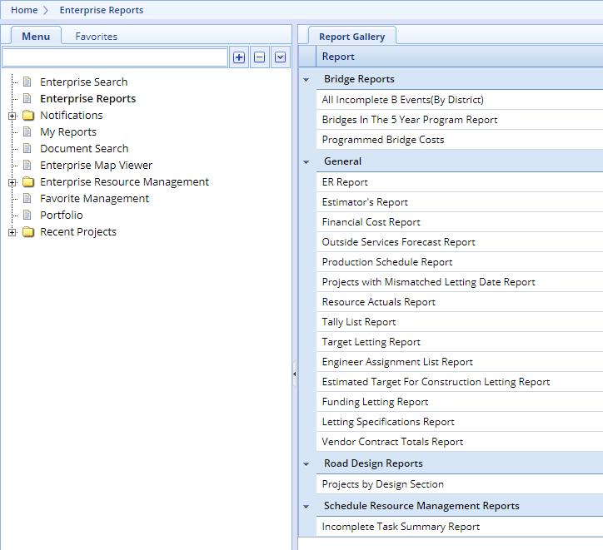

Select Incomplete Task Summary Report

Pick the dates that you want to run the report for – I went back to mid-2022 through mid-end of 2023.

Select the task codes that you want to see – I pick U2, U3, U4 events (the actual start is what we pay attention to.

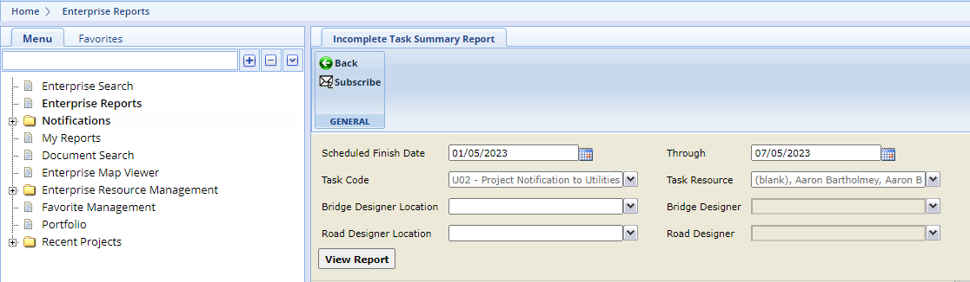

Task Resource, Bridge Designer Location, Bridge Designer, Road Designer Location, Road Designer – chose Select All

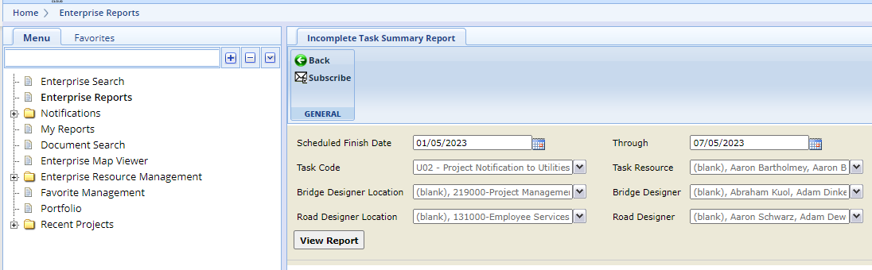

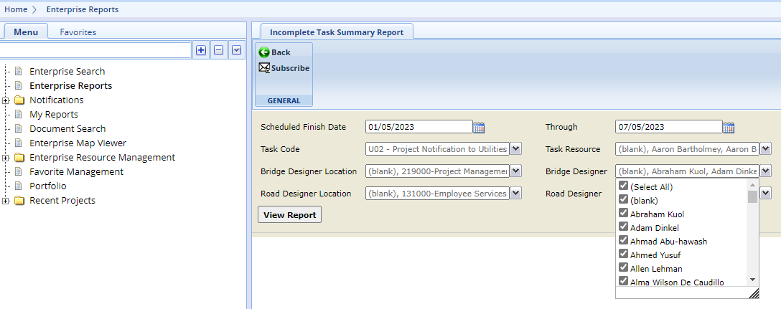

Then view report

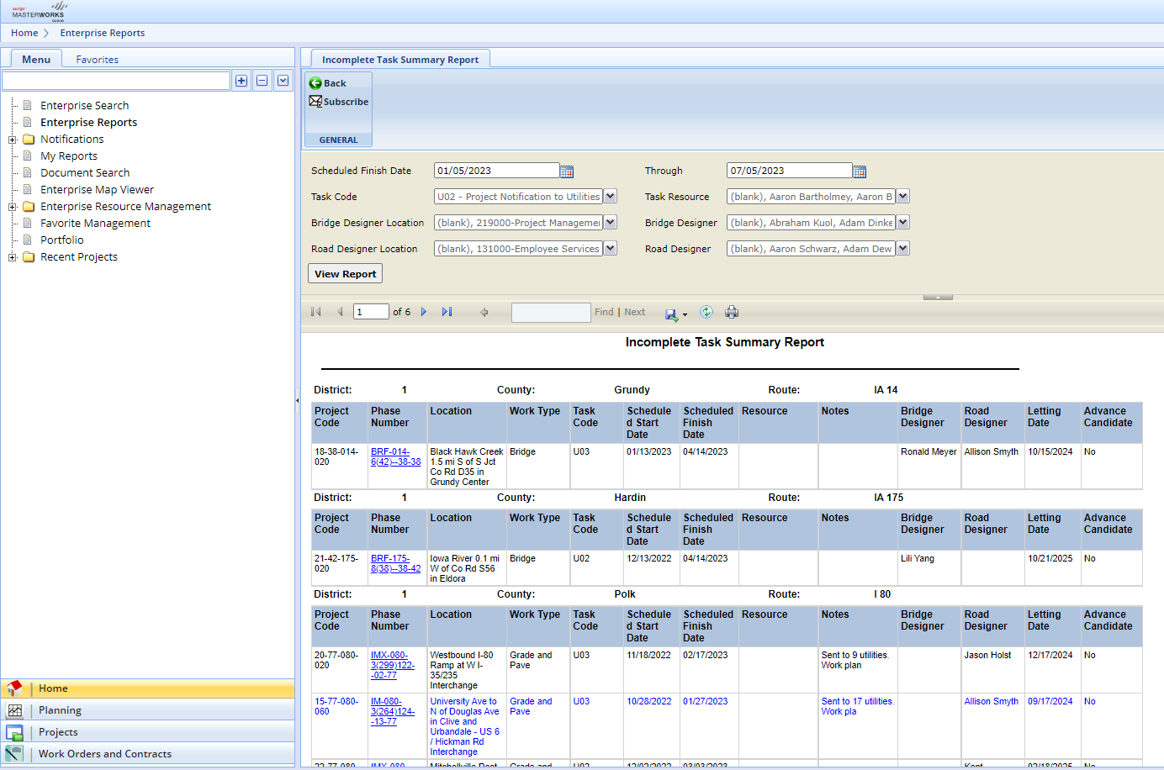

You can export to a Excel sheet, then I went through and removed items that were not my district. I am not sure if there is an easier way to remove the other districts, so you don’t have to do it by hand.