Basic “Traffic Death” message format. (4 Seconds). Actual amount will be e-mailed to Traffic.Operations.

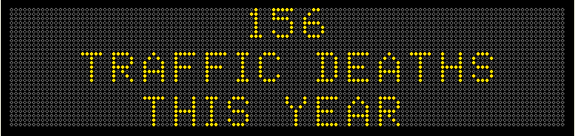

August 5, 2013 – Kickoff

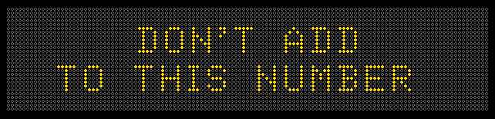

August 12, 2013

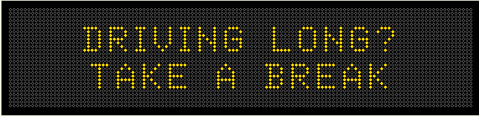

August 19, 2013

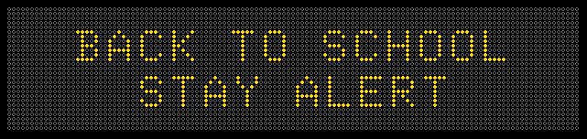

August 26, 2013 – 62 is current as of 7/29/13

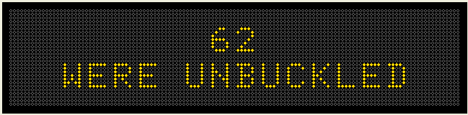

September 2, 2013 – Labor Day.

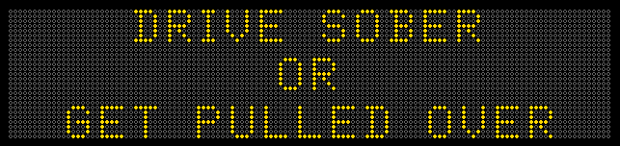

September 9, 2013

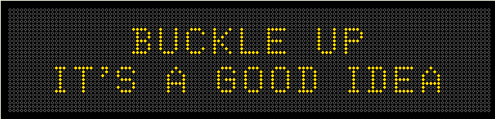

September 16, 2013

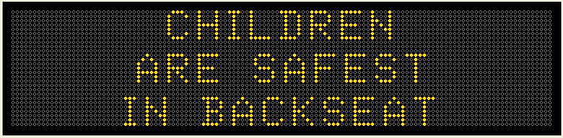

September 23, 2013

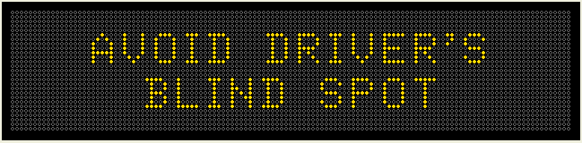

September 30, 2013

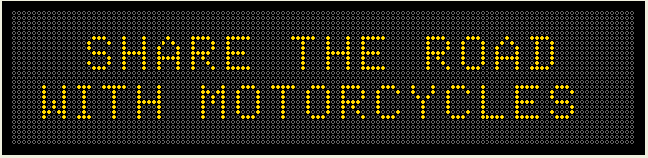

October 7, 2013

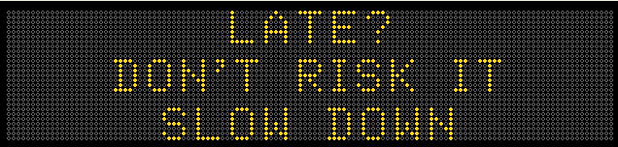

October 14, 2013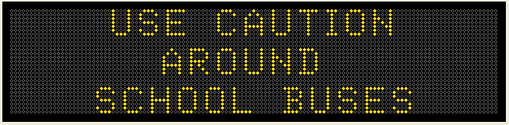

October 21, 2013 - National Teen Driver Safety Week

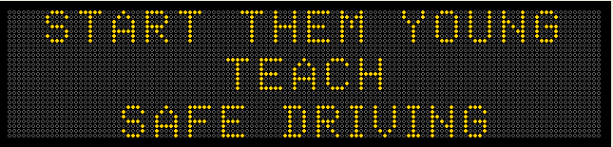

October 28, 2013 – Quantities are current as of 7/15/13.

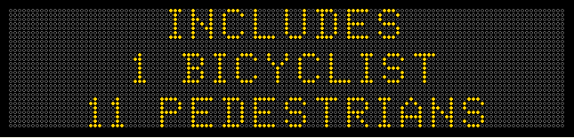

November 4, 2013

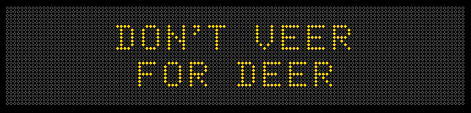

November 11th, 2013

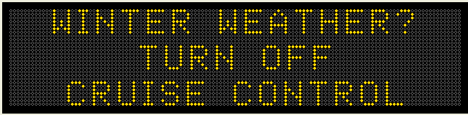

November 18, 2013

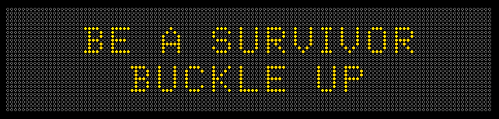

November 25, 2013

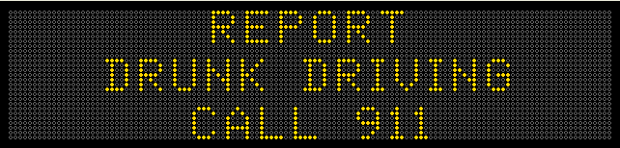

December 2, 2013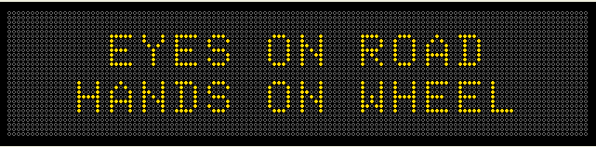

December 9, 2013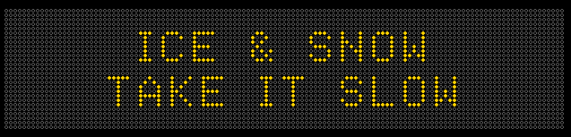

December 16, 2013

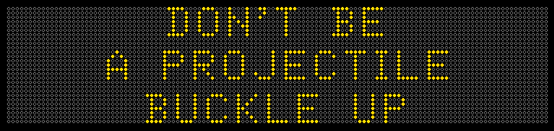

December 23, 2013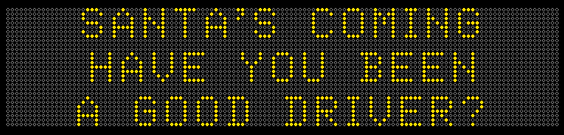

December 30, 2013 – (This is also a repeat from Sept 2nd, 2013)



January 6, 2014

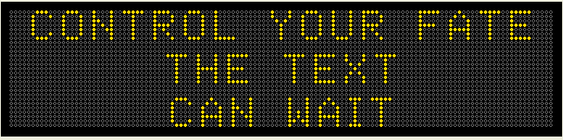

January 13, 2014

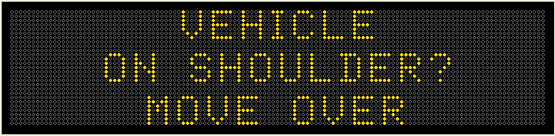

January 20, 2014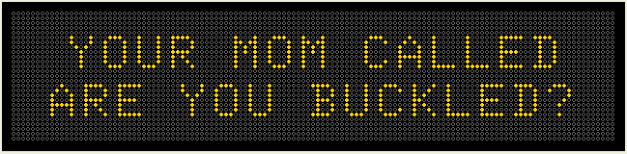

January 27, 2014

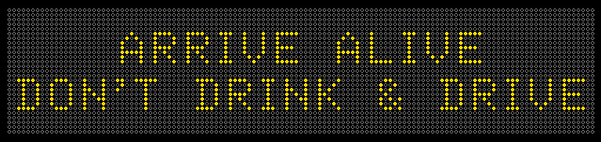

February 3, 2014 – Superbowl Monday

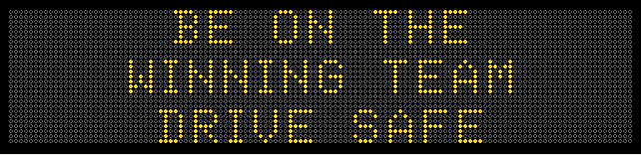

February 10, 2014

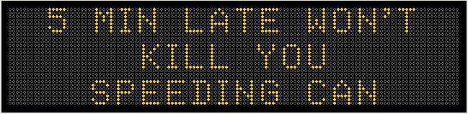

February 17, 2014

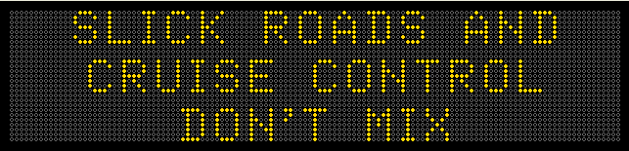

February 24, 2014

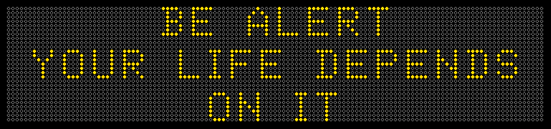

March 3, 2014

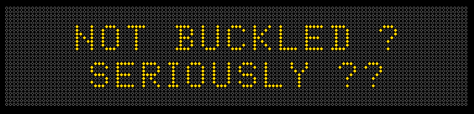

March 10, 2014

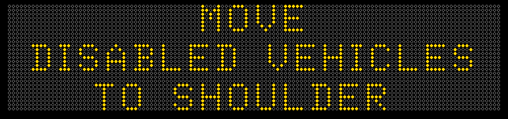

March 17, 2014 – St. Patrick’s Day

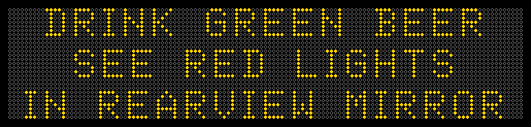

March 24, 2014 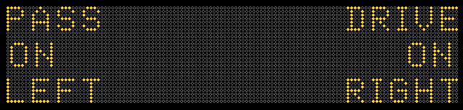

March 31, 2014 – National Workzone Awareness Week

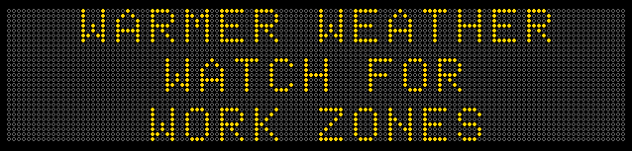

April 7, 2104

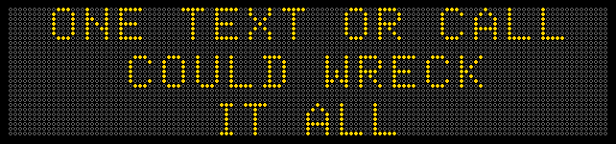

April 14, 2014

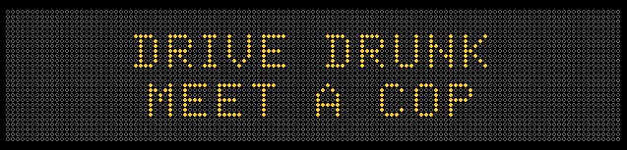

April 21, 2014

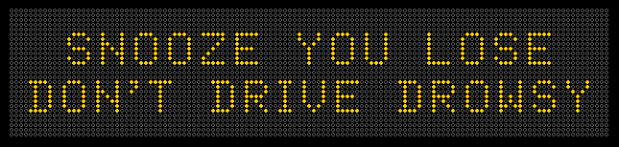

April 28, 2014 – Motorcycle Safety month in May

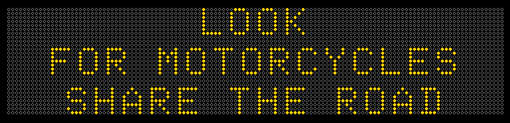

May 5, 2104

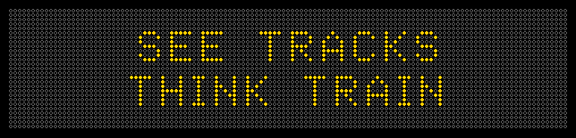

May 12, 2014 – Click it or Ticket National Campaign

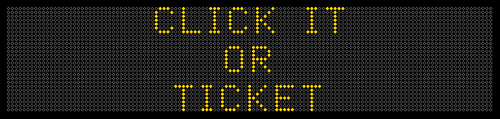

May 19, 2014 – The day after the 1st race at the Iowa Speedway

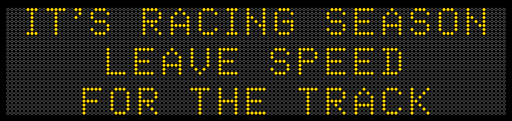

May 26, 2014 – Memorial Day

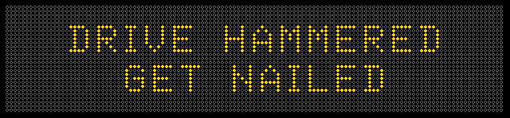

June 2, 2014 – National Tire Safety Week

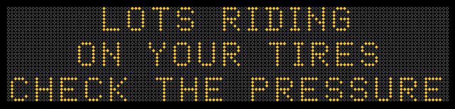

June 9, 2014 – End of School Year

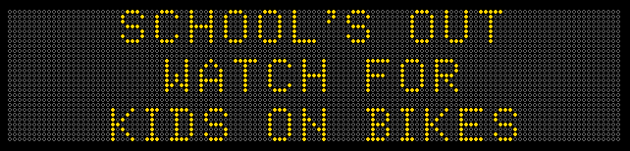

June 16, 2104

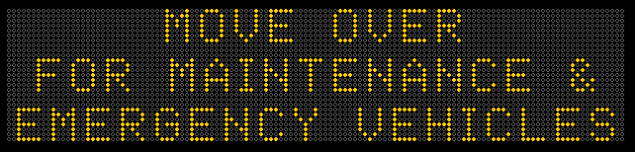

June 23, 2014

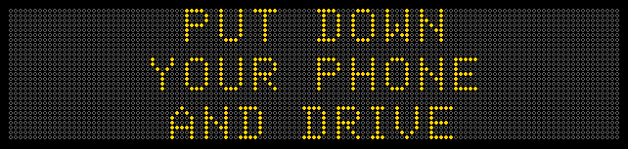

June 30, 2014

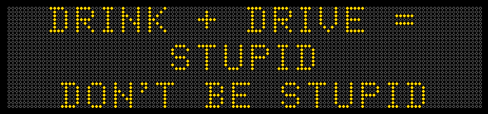

July 7, 2014 – After the 3 day July 4th weekend

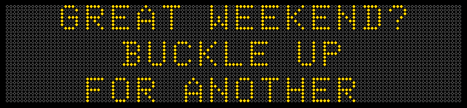

July 14, 2014

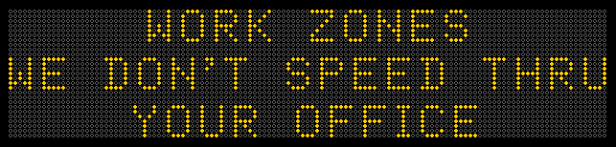

July 21, 2014

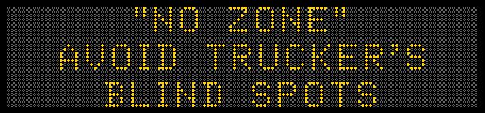

July 28, 2014

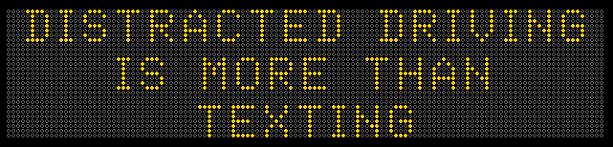

August 4, 2014

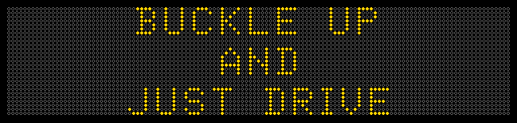

August 11, 2014 – National “Drive Sober or Get Pulled Over” campaign

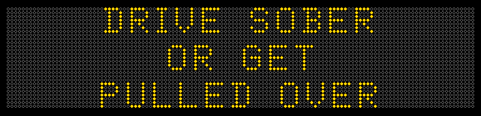

August 18th, 2014 – Back to School

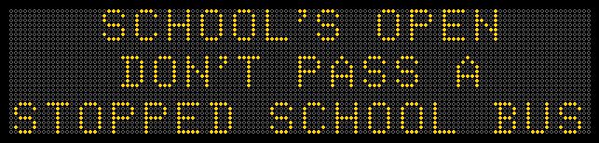

August 25, 2014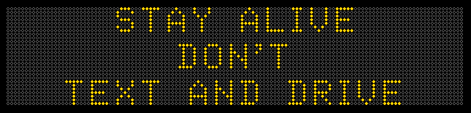

September 1, 2014 – Labor Day

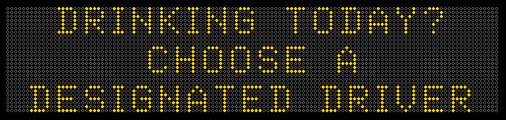

September 8th, 2014: (Monday before the Ia vs. Iowa State Football & Kickoff for Monday night football)

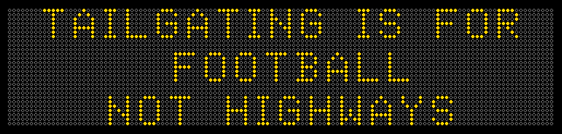

September 15th, 2014: (Child passenger Safety Week)

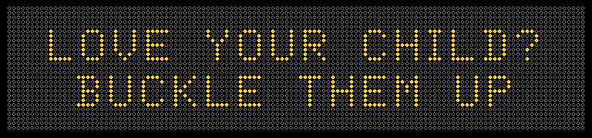

September 22nd, 2014:

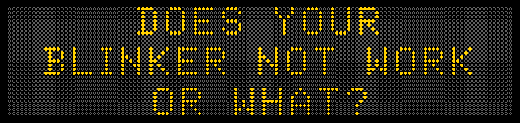

September 29th, 2014:

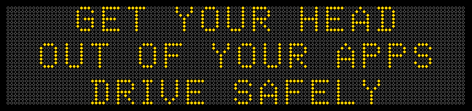

October 6, 2014:

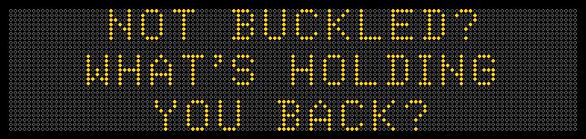

October 13th, 2014:

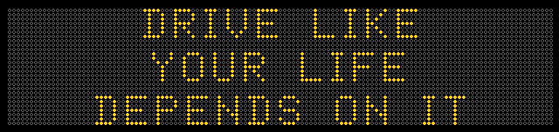

October 20th, 2014: (Teen Driver Safely Week)

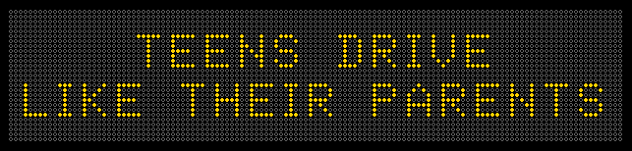

October 27th, 2014: (Halloween is the Friday of this week)

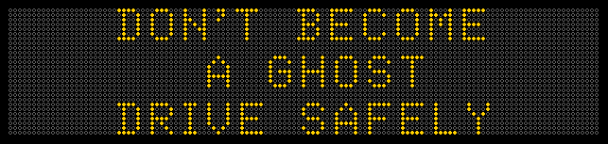

November 3rd, 2014:

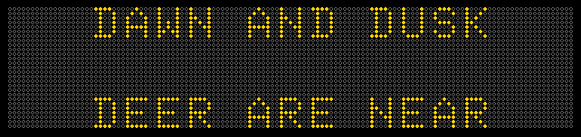

November 10th, 2014: 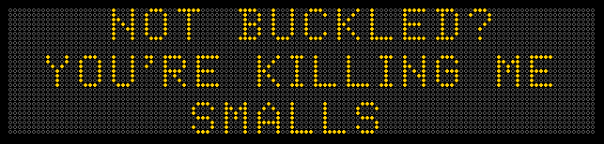

November 17th, 2014:

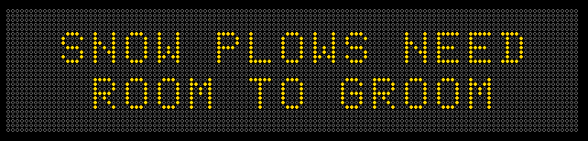

November 24th, 2014: (Week of Thanksgiving)

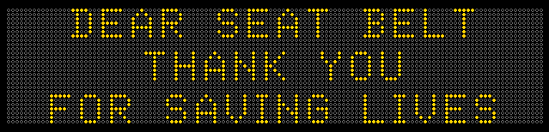

December 1st, 2014 (Impaired Driving Month)

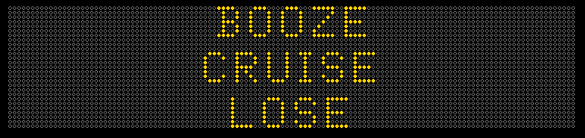

December 8th, 2014

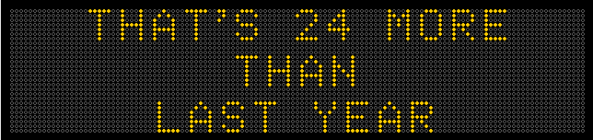

December 15th, 2014:

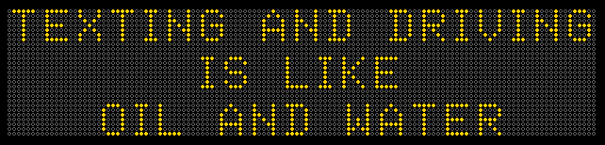

December 22, 2014: (Before Christmas on Thursday)

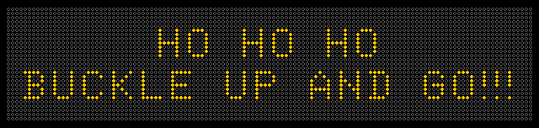

December 29th, 2014: (Before New Year’s Eve on Wednesday)

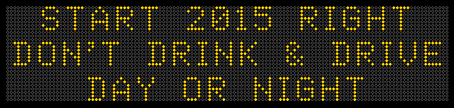

January 5th, 2015: **Did not actually go on signs due to Winter Storm**. E-mail, FB and Tweeter went out.

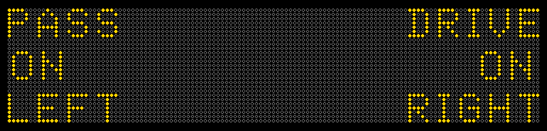

January 12th, 2015:

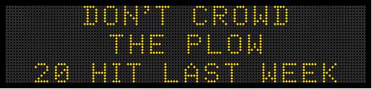

January 19th, 2015

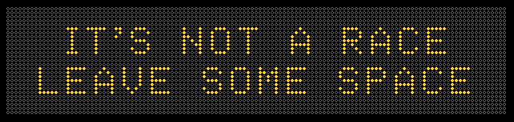

January 26th, 2015:

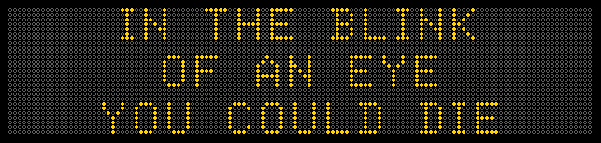

February 2nd, 2015: (Groundhog Day)

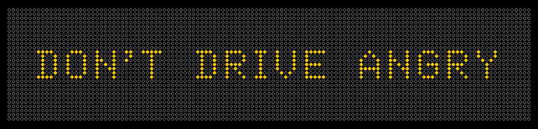

February 9th, 2015

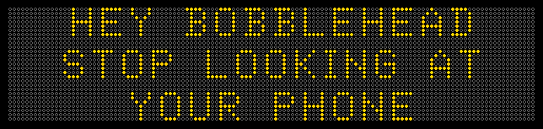

February 16th, 2015:

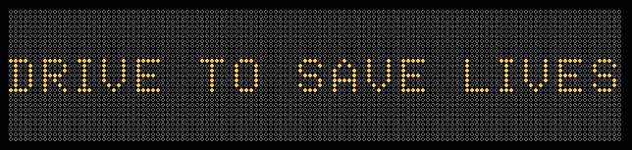

February 23rd, 2015:



March 2nd, 2015:

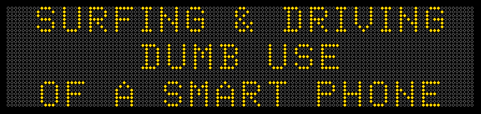

March 9th, 2015:

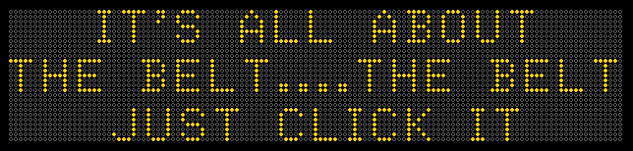

March 16th, 2015: (Day before St. Pat’s)

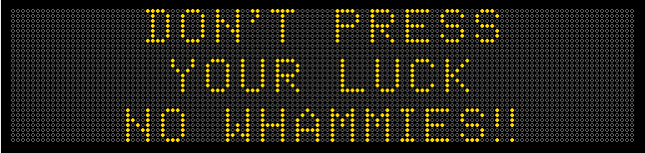

March 23rd, 2015: (Workzone Safety Awareness Week) 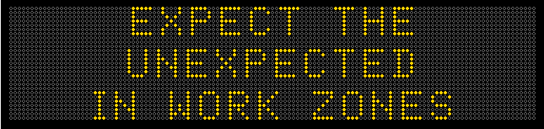

March 30th, 2015: (March Maddness – Final 4 is April 4th, Championship is April 6th.) (4 Seconds)

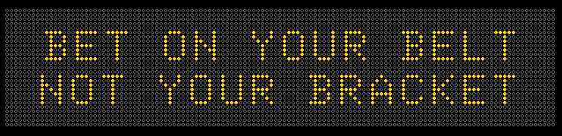

April 6th, 2015: (4 Seconds)

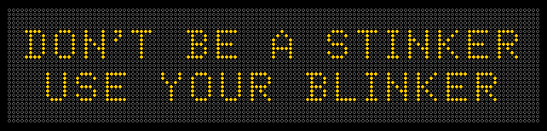

April 13th, 2015: (3.5 Seconds)

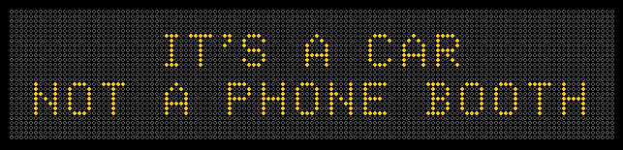

April 20th, 2015: (3 Seconds)

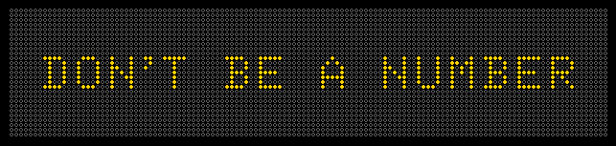

April 27th, 2015: (3.5 Seconds) (Tracey’s video - <https://www.youtube.com/watch?v=ZjugYzQd-mg>)

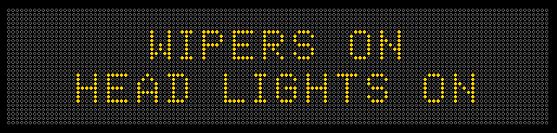

May 4th, 2015: (5 Seconds)

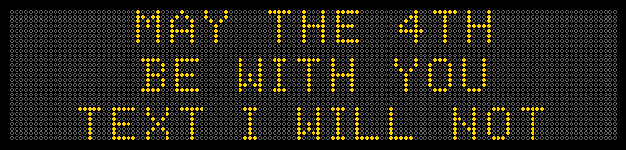

May 11th, 2015: (4 Seconds)

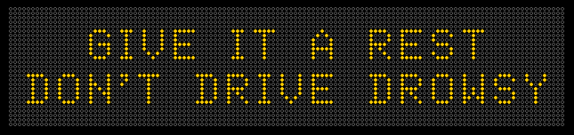

May 18th, 2015: (3.5 Seconds)

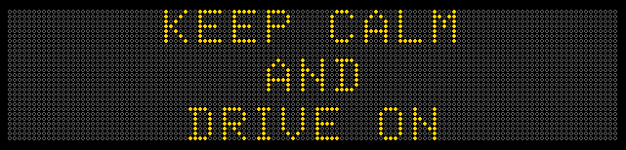

May 25th, 2015: (Memorial Day) (3.5 Seconds)

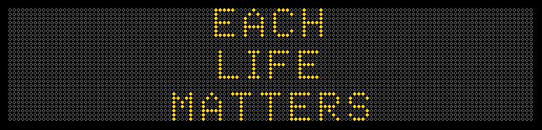

June 1st, 2015: (5 Seconds)

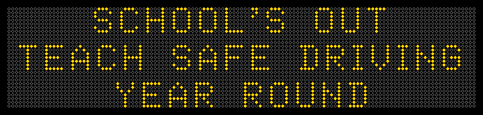

June 8th, 2015: (4 Seconds)

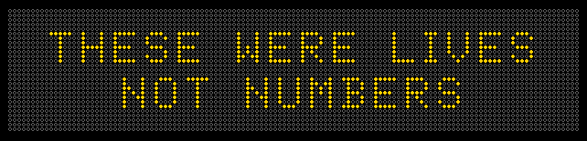

June 15th, 2015: (Day after Father’s Day) (3.5 Seconds)

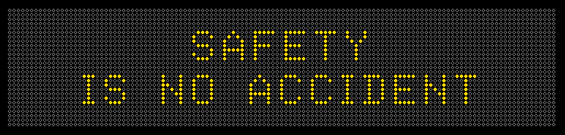

June 22, 2015: (4 Seconds)

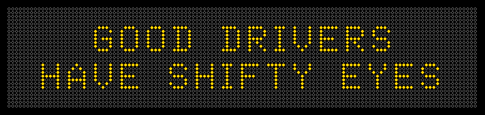

June 29th, 2015: (4 Seconds)

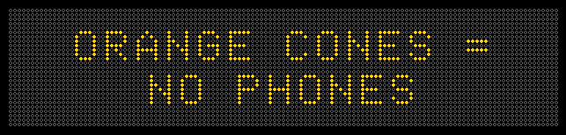

July 6th, 2015: (4.5 Seconds)

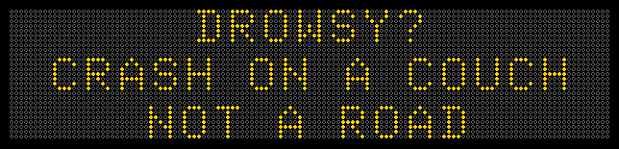

July 13th, 2015: (4.5 seconds) Hot Car / Baby topic – No national campaign.

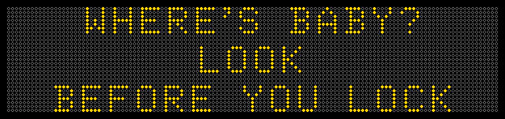

July 20th, 2015: (4.5 seconds)

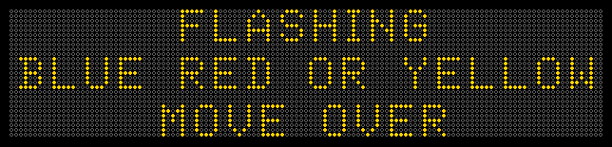

July 27th, 2015: (5 Seconds)

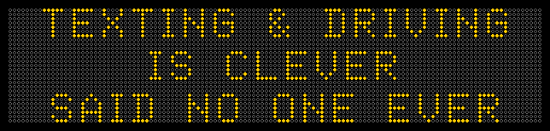

August 3rd, 2015: (4 Seconds)

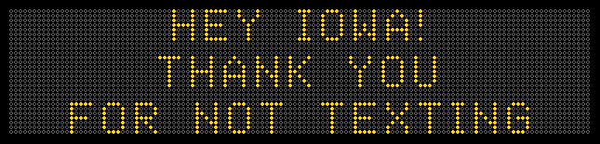

August 10th, 2015: (4.5 Seconds)

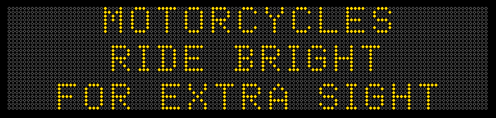

August 17th, 2015: (5 Seconds)

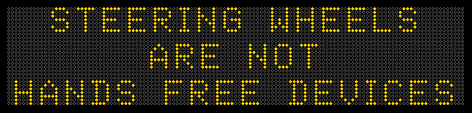

August 24th, 2015: (3.5 Seconds) National Impaired Driving (Aug 19 to Sept 7th)

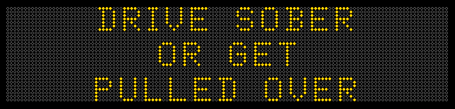

August 31st, 2015: (3.5 Seconds) 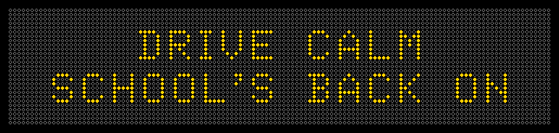

September 7th, 2015 (Labor Day) (4 Seconds)

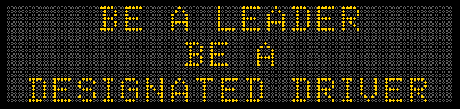

September 14th, 2015: (Child Passenger Safety Week – 9/13 to 9/19) (3.5 Seconds)

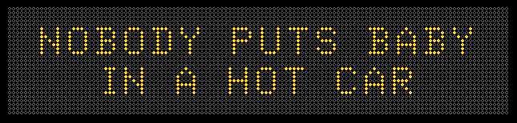

September 21st, 2015: (4.5 Seconds)

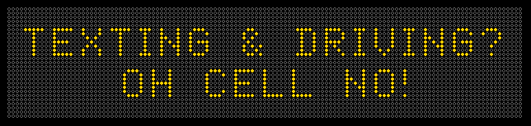

September 28th, 2015: (3.5 Seconds)

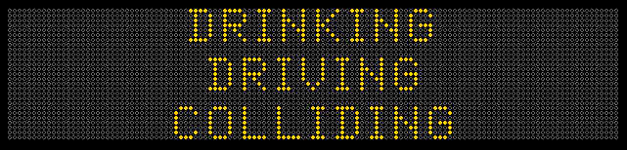

October 5th, 2015: (3.5 Seconds)

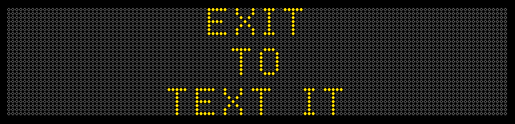

October 12th, 2015: (5 Seconds) Columbus Day – Play on Exploration and Field of Dreams.

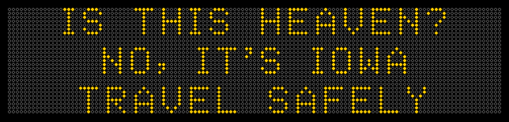

October 19th, 2015: National Teen Driver Safety Week – (5 Seconds)

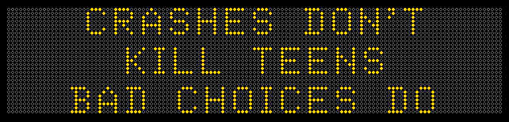

October 26th, 2015: (5 Seconds)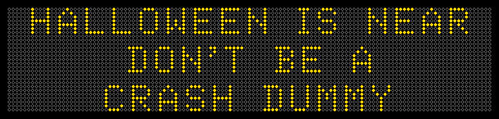

November 2nd, 2015: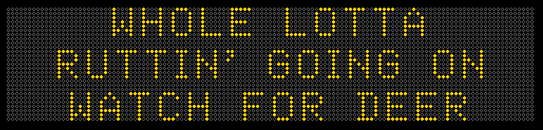

November 9th, 2015:

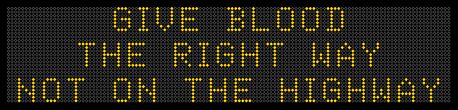

November 16th, 2015: ( Seconds) (From city of Toronto)

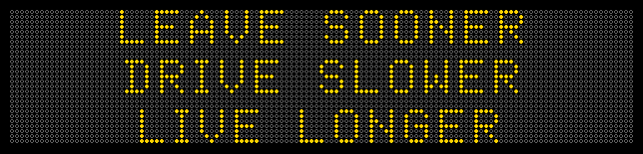

November 23rd, 2015: ( 4.5 Seconds) Monday before Thanksgiving.

This is the national NHTSA’s safety campign around Thanksgiving. Below was taken from their website.

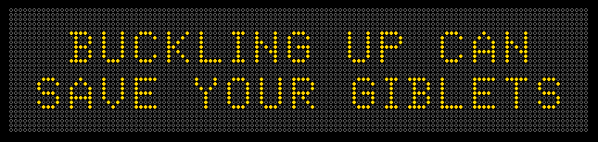

November 30th, 2015: (5.0 Seconds) (From Steve Staebler – DOTer)

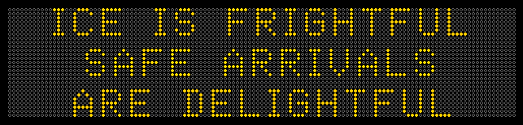

December 7th, 2015: (4.0 Seconds) 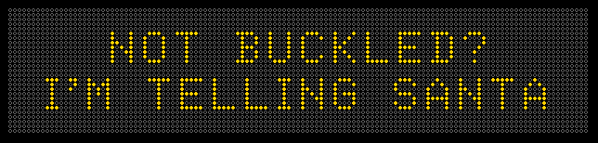

December 14th, 2015: ( Varies Seconds) Five different messages

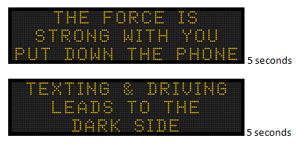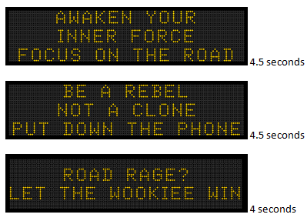

December 21st, 2015: (4.5 Seconds) (From NSEL survey)

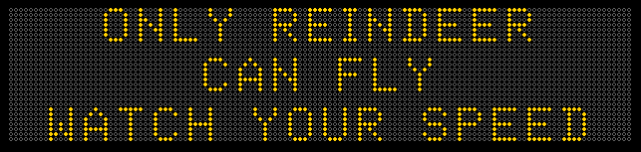

December 28th, 2015: **Did not actually go on signs due to Winter Storm**. E-mail, FB Tweeter went out.

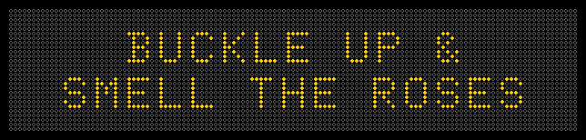

January 4th, 2016: (3.5 Seconds) (From Willy / bumper sticker)

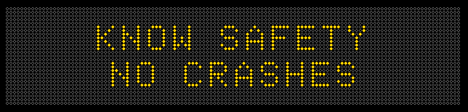

January 11th, 2016: (4.0 Seconds) (Spin on sign from Illinois DOT)

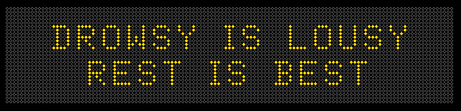

January 18th, 2016: (4.0 Seconds) (MLK Holiday)

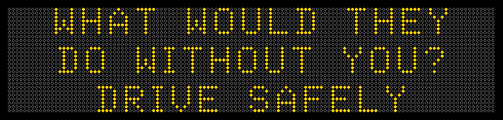

January 25th, 2016: (5.0 Seconds) (Ray Reynold’s son)

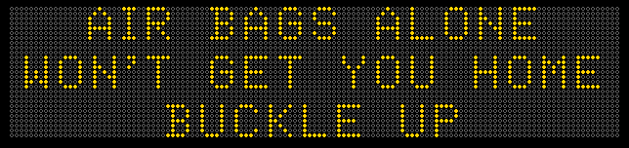

February 1st, 2016: (4.5 Seconds)

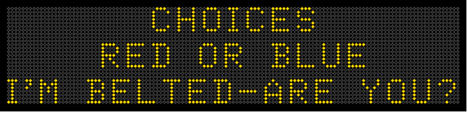

February 8th, 2016: (4.5 Seconds) : **Did not actually go on signs due to Winter Storm until 6pm.** 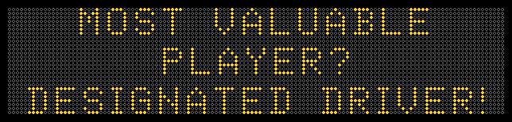

February 15th, 2016: (4.0 seconds) (Day after Valentine’s Day…. )

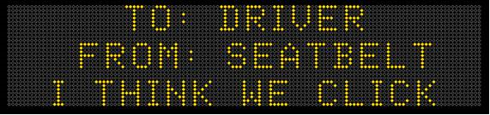

February 22, 2016: (5.0 Seconds)

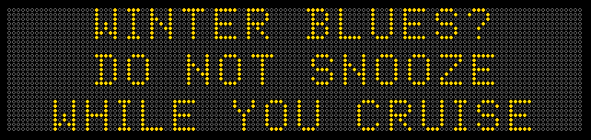

February 29th, 2016: (4.5 Seconds). Leap Day! (Willy/Tracey)

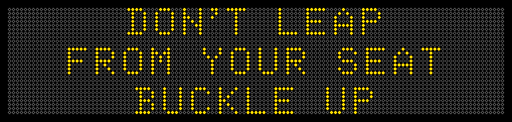

March 7th, 2016: (3.5 Seconds)

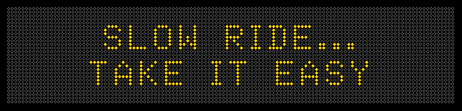

March 14th, 2016: (4.0 seconds). Day after the NCAA Selection Sunday. (Tracey/Willy)

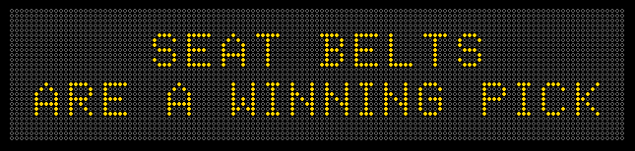

March 21th, 2016: (4.5 seconds) (adapted from NSEL survey)

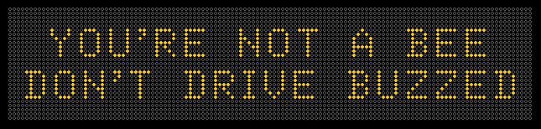

March 28th, 2016: (4.0 Seconds) (public input – gohawks370@gmail.com)

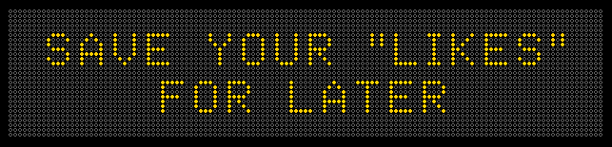

April 4th, 2016: (4.0 Seconds) April is National Distracted Driving Month. (From Michael Pawlovich)

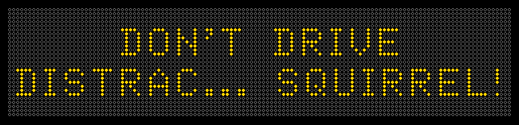

April 11th, 2016:

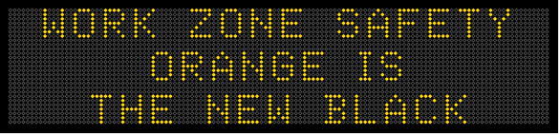

April 18th, 2016: (4.5 Seconds)

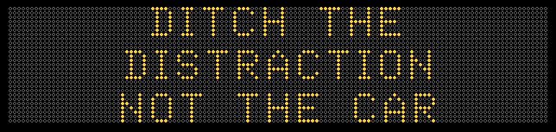

April 25th, 2016: (4.0 Seconds) (Tracey)

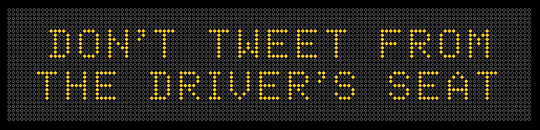

May 2nd, 2016: (4.5 Seconds) (from MoDOT – Willy & DOTer Jeremy Johnson-Miller)

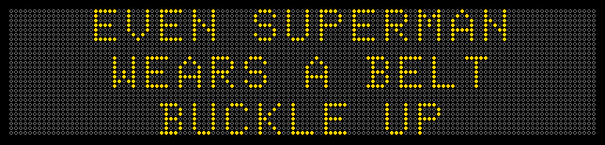

May 9th, 2016: (4.5 Seconds) (Tracey/Willy)

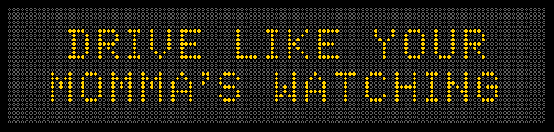

May 16th, 2016: (5.0 Seconds) (Willy / sign on internet)

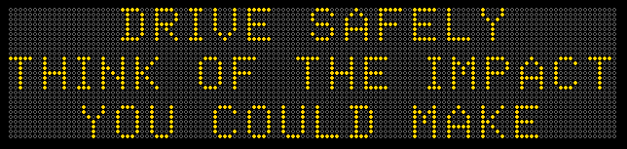

May 23rd, 2016: (4.5 Seconds) (Use the cop Dover PD video)

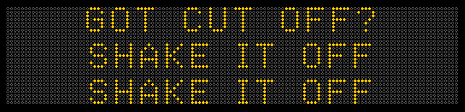

May 30th, 2016: (5.0 Seconds) Memorial Day

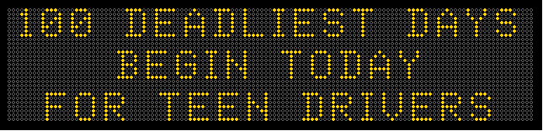

June 6th, 2016: (5.0 Seconds) 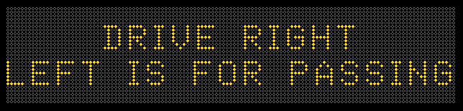

June 13th, 2016: (4.5 Seconds) (Willy/Tracey/Andrea/whole team)

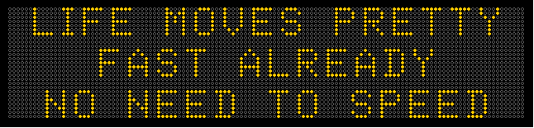

June 20th, 2016: (5.0 Seconds) National ride to work day…. Motorcycle message (Willy/Tracey/Team)

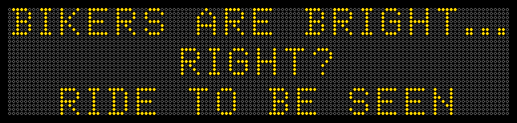

June 27th, 2016: (5.0 Seconds)

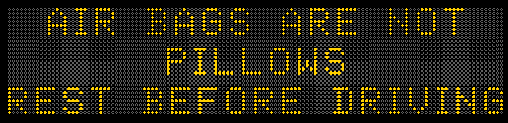

July 4th, 2016: (5.0 Seconds) Willy/Tracey/Katy Perry

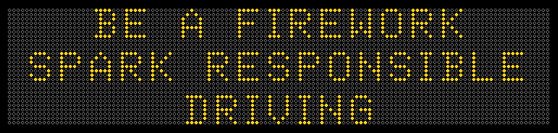

July 11, 2016: (4.5 seconds)

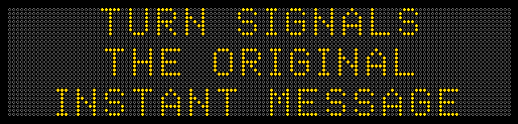

July 18th, 2016: (5.0 Seconds) Ghostbusters is released on Friday July 15th)

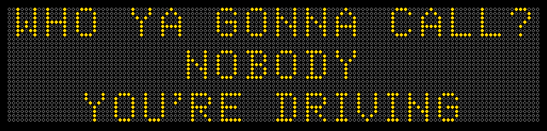

July 25th, 2016: (5.0 Seconds)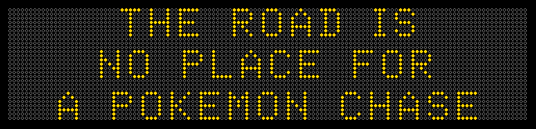

August 1, 2016: (4.0 seconds) Olympics start on Friday, Aug 5th

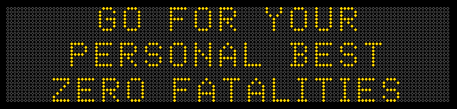

August 8, 2016 (5.5 seconds)

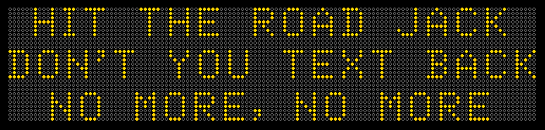

August 15, 2016 (3.5 seconds)

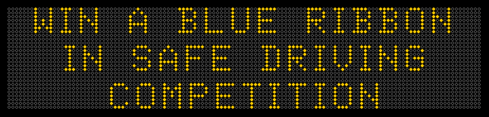

August 22, 2016: (4.5 sec) Back to School. Statewide starts can’t sooner than Aug 23rd. 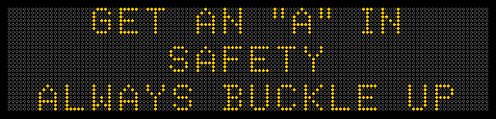

August 29, 2016 (4.0 sec)

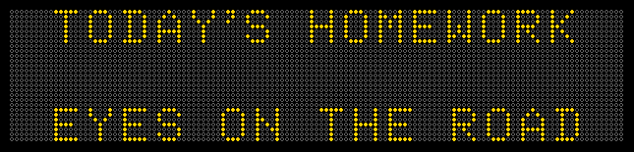

September 5, 2016 (5.0 seconds) (Iowa / Iowa State Football this weekend, Sept 10th in Iowa City)

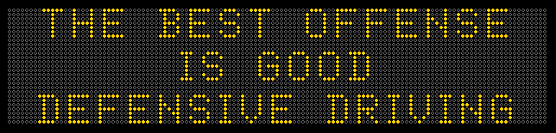

September 12, 2016 (5.0 seconds)

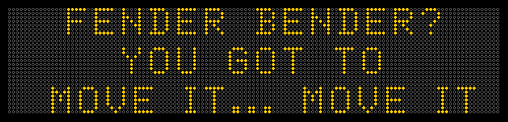

September 19, 2016; (4.0 seconds)

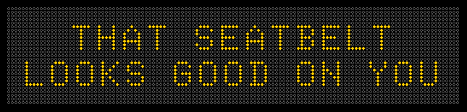

September 26, 2016: (4.5 seconds)

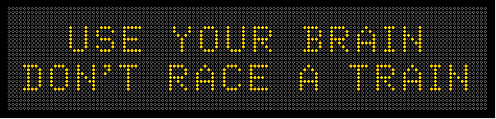

October 3, 2016 (5.0 seconds)

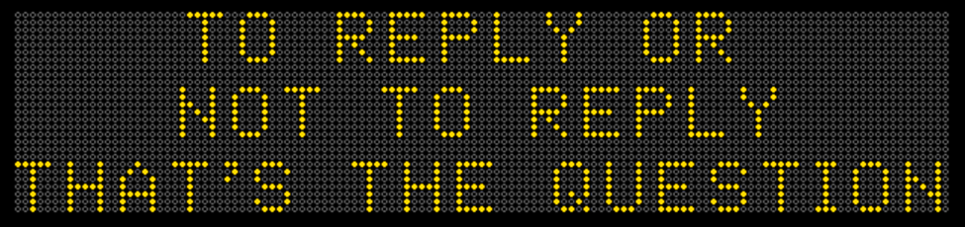

October 10, 2016: Columbus Day (5.0 seconds)

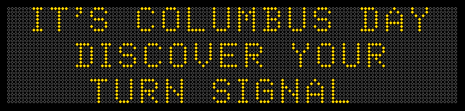

October 17, 2016: (5.0 seconds)

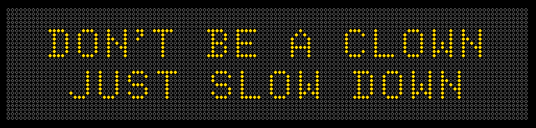

October 24, 2016: (5.0 seconds)

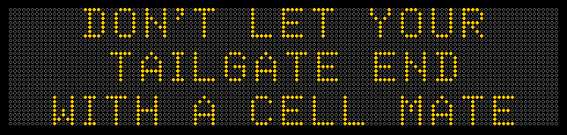

October 31, 2016: (Real Halloween) (4.5 seconds)

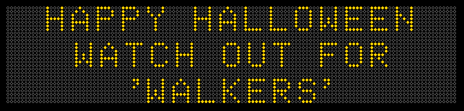

November 7, 2016: Election Day contest winner or this one, whichever is better.

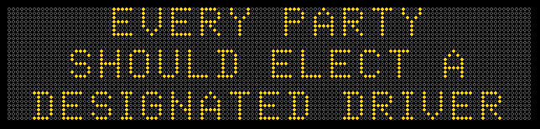

November 14, 2016: (Deer Rut, later in season for 2016) (5.0 seconds)

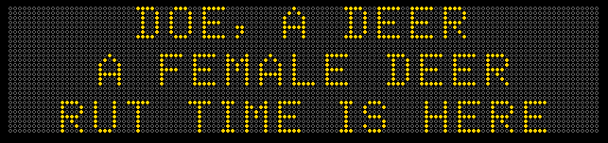

November 21st , 2016: (3.5 Seconds) Monday before Thanksgiving (11/24/16).

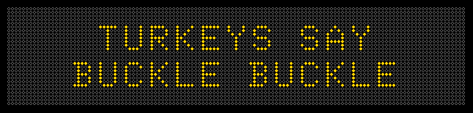

November 28, 2016: (4.5 seconds) (Monday after black Friday)

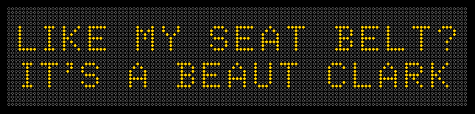

December 5, 2016: (4.5 seconds)

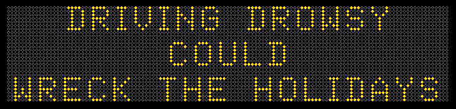

.

December 12th, 2016: (5.5 seconds)

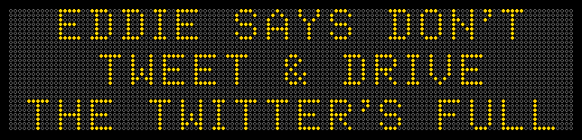

December 19, 2016: (4.0 seconds)

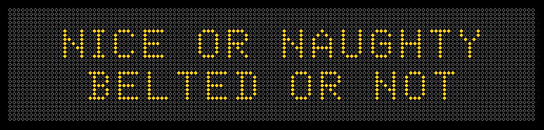

December 26th, 2016 (4.0 seconds)

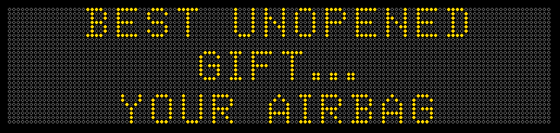

January 2nd, 2017: (5.0 seconds)

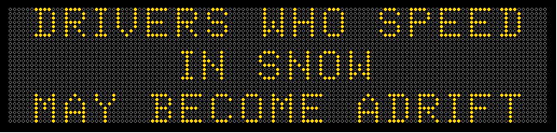

January 9th, 2017: (5.0 seconds)

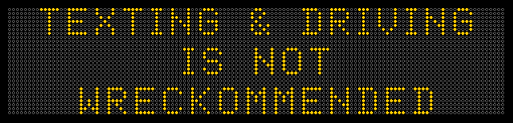

January 16th, 2017 (5.0 seconds)

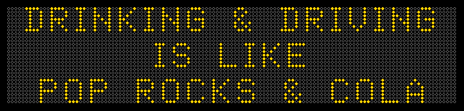

January 23, 2017 (3.5 seconds)

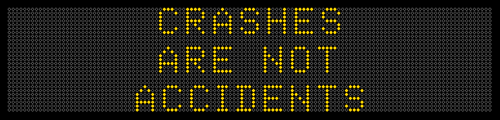

January 30th, 2017 (5.0 seconds)

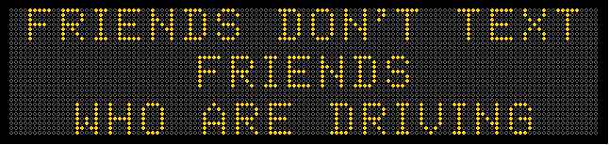

February 6th, 2017 (5.5 seconds)

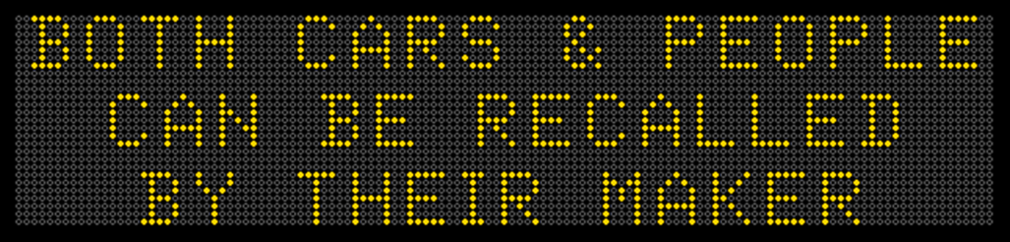

February 13th, 2017: (4.0 seconds) Day before Valentine’s day

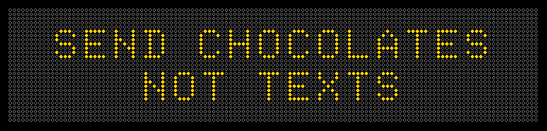

February 20, 2017: (5.0 Seconds) President’s day

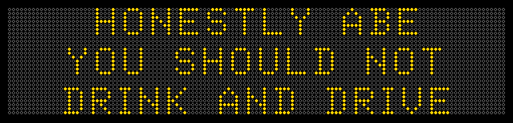 Ran from Midnight to about 11:45am

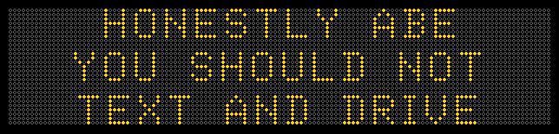

February 27th, 2017: (4.5 seconds)

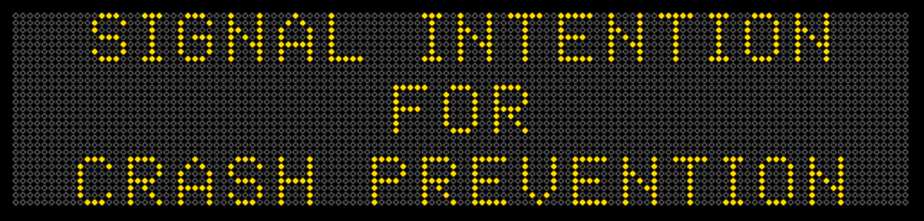

March 6th, 2017: (4.5 seconds)

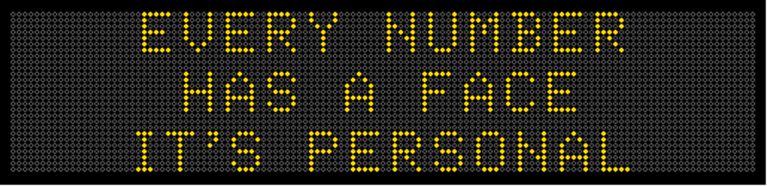

March 13, 2017 – Selection Sunday is March 12th – 1st & 2nd round 16th-19th 5.0 sec

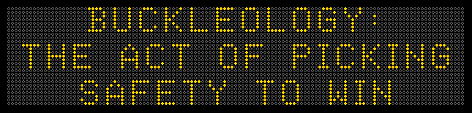

March 20, 2017 3.5 sec 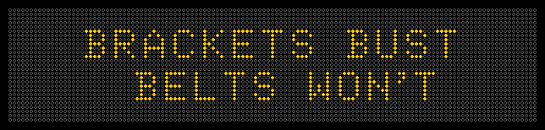

March 27, 2017 4.5 sec

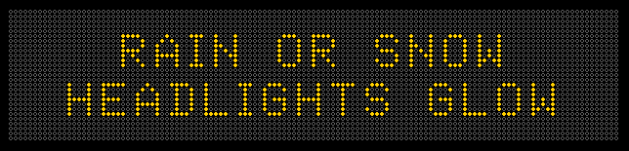

April 3, 2017 (Opening day of baseball) 4.5 sec

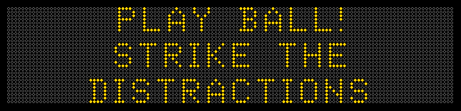

April 10, 2017 4.5 sec

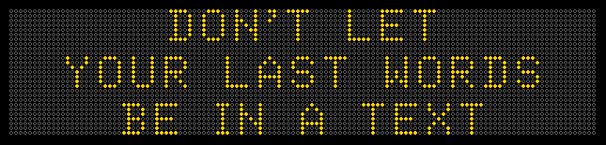

April 17, 2017 4.0 sec

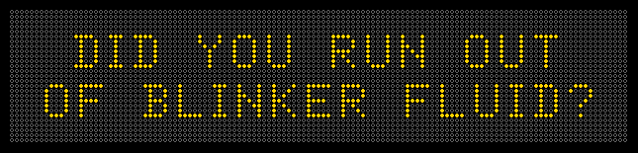

April 24, 2017 5.0 sec

