**Traffic Deaths & Safety Messages on DMS Guidelines**

**8/2/13 Created, Updated 4/9/14**

**Final, Approved – DOT Management**

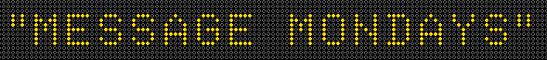

**Background:**

In an effort to increase public awareness of traffic deaths on Iowa roadways, the Iowa DOT will be implementing messages on Dynamic Message Signs (DMS). This safety initiative will be known as “Message Mondays”. The 1st panel of the message will contain the aggregate number of traffic deaths that have occurred since the start of the calendar year. The 2nd panel will have a safety related message that is intended to influence the driver about their actions and driving behavior.

**When to Display:**

The first Monday of the campaign was August 5th, 2013 from 12:00 a.m. to 11:59 p.m. It was to continue every Monday, through the remainder of calendar 2013 as a test deployment. In early 2014, DOT management reviewed the program decided to continue with it until further notice.

**Which DMS will be used?**

* YES -- All overhead DMS
* YES – All Rest Area DMS
* NO -- Side-Mount and portable DMS

**Official Count of Traffic Deaths:**

The Motor Vehicle Division sends a daily e-mail with the current traffic fatality count to an existing distribution list. Staff from the Operations Support Center ([IowaDOT.Traffic@dot.iowa.gov](mailto:IowaDOT.Traffic@dot.iowa.gov)) has been added to this list.

The total fatalities from the Friday prior to the next week’s message will be initially used. By 11:00 a.m. each Monday, the Motor Vehicle Division will update the fatality count from the weekend and provide this number to the Operations Support Center whom in-turn will update the DMS message.

**How does the Traffic Deaths Message work with other messages? (Incident, Weather, Travel Time, etc)?**

The traffic deaths message has the lowest priority. It will be displayed ONLY when no other message supersedes. Examples of superseding messages are lane closures, crashes, detours, weather warnings, AMBER alerts, travel times, etc.

**Coordination with other Outreach Efforts:**

The topics for the 2nd panel safety message have been coordinated with the National Highway Traffic Safety Administration’s (NHTSA) and the Iowa Governor’s Traffic Safety Bureau (GTSB) outreach campaigns.

The Office of Strategic Communications will use social media to disseminate information about “Message Mondays”. The information on Facebook, Twitter and DOT’s web page (future possibility) will be updated each Monday to provide additional information about that week’s safety message.

**Actual Message:**

**1st panel (2.5 seconds)**

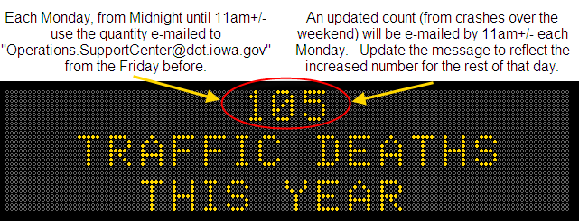

**2nd panel (display time varies by message) – Different each week**

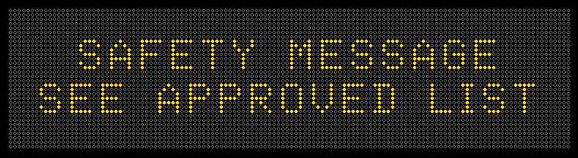

**Actual Message (for Rest Area DMS):**

During Message Mondays, the “Welcome and Time/Temp” DMS message will be removed. The traffic deaths message, using the same message format as the overhead DMS, will be used.

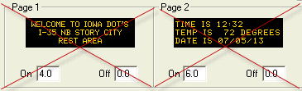 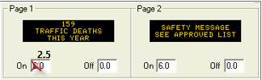

**Approved 2nd Panel Safety Messages:**

Since each week will display a different Safety Message, the pre-determined 2nd panel Safety Message will be pre-approved in six month time frames. The approved messages for March 3, 2014 to September 8th, 2014 can be found in the following pages.

**Changing the Planned 2nd Panel Safety Message:**

There will be times during the six months of approved messages where the 2nd panel safety message will be changed to coincide with national campaigns or local events that were unknown during the creation of the six month calendar. Any changes will be jointly reviewed and approved by the Office of Traffic & Safety and the Office of Strategic Communications and shared with the Office of Traffic Operations prior to implementation.