

**Message Monday**

**Public Outreach Program**

**Office of Traffic & Safety and**

**Office of Strategic Communications**

**April 30, 2015**

As part of a multi-agency Zero Fatalities (ZF) program, the Iowa DOT uses 72 dynamic message boards to weekly display the current year-to-date fatality count, along with a thought-provoking safety message. The intent is to start a conversation during the 12 seconds drivers see the DMS and extends to the water cooler, dinner table and social events. "Hey, did you see..."

The messages all relate to general highway safety including one of the five behaviors outlined in Iowa's ZF program: drive alert; drive sober; slow down; buckle up; stay alert.

Non-repeated messages run only on Mondays. The fatality count is a somber reminder and when coupled with a witty message, the dichotomy is memorable. Morning commuters see the fatality number as reported on Friday. As they travel home, the number may have changed to include any weekend fatalities. This is another way to get a conversation started.

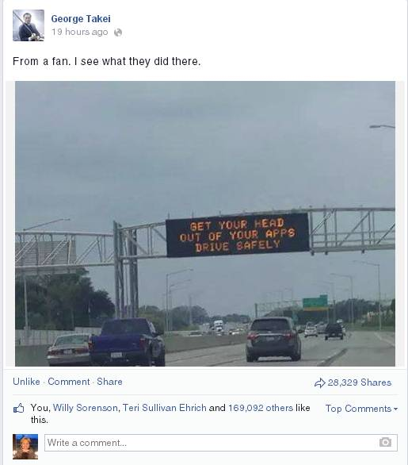Ideas for the messages come from a variety of sources, including the public. The safety messages are then crafted to correspond with calendar events, pop culture, humor, or facts. The most successful messages have been non-traditional using humor or heart string tugs.

To extend the reach, messages are promoted on ZF and Iowa DOT Facebook (37,491 followers) and Twitter (32,100 followers) accounts. Public and private organizations have signed up for weekly emails from the ZF blog to share with their employees. City of Des Moines posts messages on their DMS.

The vast majority of comments from the public are positive. Comments received are proportional to the edginess of the message. Our most popular has been “Get your head out of your apps – drive safety.” This message drove many local and national media stories as well as thousands of comments on social media. For those who express concerns, we take the opportunity to explain the intent of the program. By the end of that conversation, the detractors often end up supplying us with their own messages to consider.