**Iowa DOT’s Message Monday Program**

**Each message must be…**

1) related to transportation safety.

2) general enough for any sign in Iowa. (Nothing specific to a City or region).

3) able to fit on the message board. (18 characters wide by 3 lines tall)

Idea #1: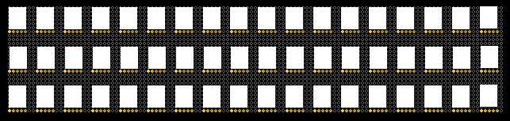

Idea #2:

Idea #3: