Iowa DOT Network Scoring System Overview for Interchanges

Each interchange in the state has been scored and ranked for wrong way driving risk. Interchanges are scored on five categories:

1. Crash History
2. History of Non-Crash Events
3. Interchange Geometry
4. Proximity to an Address with a Liquor License
5. Traffic Volume
6. Example Calculation
7. Sample Scoring Worksheet

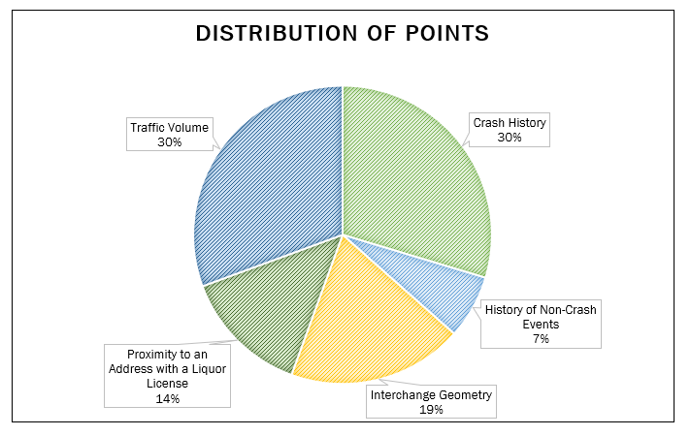

Interchanges receive points under each category as explained below. A higher score means a higher wrong-way risk, and a higher priority for this project.

The point system described below was based on trying to keep the percentages in the pie chart close to what was described. We did not want any one category to overpower another category, so we used an iterative process to find the right point assignment combination to equally distribute all the points.

A spreadsheet that contained all of the crash data, non-crash events, volumes, geometry and distance to liquor store was used to allow for easy calculation of points for Iowa’s 434 interchanges

Detailed Review of Scoring Categories

1. Crash History

All crashes involving a wrong way driver between 2008 and 2020 are cataloged. The wrong way driver’s point of entry or possible points of entry are found using information from the crash report, our camera network, news media, and 911 calls. Each crash is assigned to an interchange (or split between 2-4 interchanges according to the estimated probability that each was the point of entry).

Each crash counts equally regardless of number of vehicles, severity, or property damage with the exception of *fatal* crashes. An additional 75 points are added to the score of each fatal crash.

1. History of Non-Crash Events

Non-crash events are defined as any known incidence of wrong way driving that does not result in a crash. The point of entry or possible points of entry are assigned the same way as for crashes. Each non-crash event adds 10 points to an interchange’s score, up to a maximum of 50 points from this category.

1. Interchange Geometry

Interchange styles known to generate more wrong way drivers are scored higher. Unique interchanges, including folded diamonds (Parc-lo “B” and Parc-lo “AB” with the exit ramp on the inside of the loop, have 50 points added to their score.

*Example: Folded Diamond (Parclo “B”) with Exit Ramp on Inside of Loop (50 points)*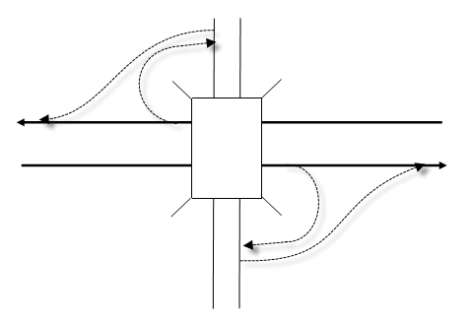

Standard folded diamonds, where the exit ramp is on the outside, (Parclo “A” are not considered high-risk and do not receive points under this category.

*Example: Standard Folded Diamond (no points for geometry)*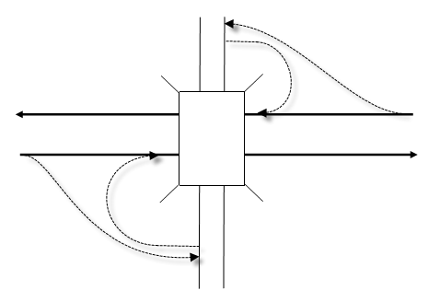

Split interchanges, where opposite directions of the mainline exit onto different side roads, receive 25 points for geometry.

*Example: Split Interchange*  
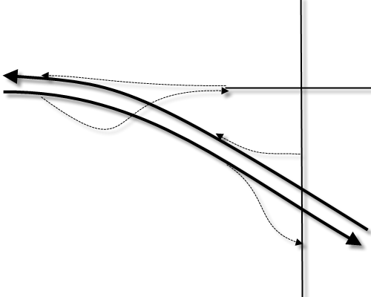

1. Proximity to an Address with a Liquor License

Wrong way driving events often involve alcohol, so interchanges are scored higher if they are near liquor vendors. Interchanges within 0.7 miles (as the crow flies) of a liquor license receive 10 points; interchanges between 0.7 miles and 2.0 miles from a liquor license receive 5 points.

1. Traffic Volume

Wrong way driving is more frequent on higher-volume interchanges. Interchanges with a mainline volume in the 10th percentile of AADTs receive 1 point, in the 20th percentile receive 2 points, and so on. Percentile is rounded up, so an AADT at the 83rd percentile receives 9 points. Points are added in the same way based on side road volume (at interchanges with two approaches, the higher-volume approach is used).

If both the mainline and side road are in the top 30% of AADTs, the interchange receives an additional five points in this category.

1. 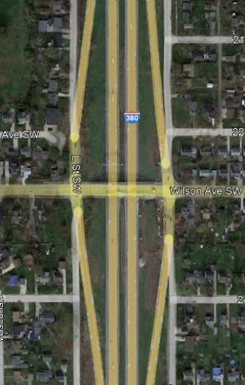Example:

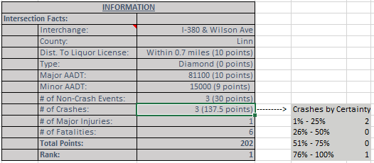

Crash Data for this interchange



**Location: I-380 and Wilson Ave**

* 1. **Number of (WWD Related) Crashes** – 3 (Fatal or non-fatal)
     1. 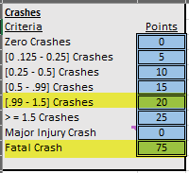2 crashes where the “certainty” was between 1% and 25% = 2 * .25 = 0.5 crashes
     2. 1 crash where the “certainty” was between 76% and 100% = 1 *100 = 1.0 crashes
     3. 0.5 crashes + 1 crash = 1.5 crashes = 20 points
     4. Fatals = 75 points for each fatal crash
        1. Crash on 11/18/12 was 25% certainty, .25 *75 = 18.75 points
        2. Crash on 7/5/2016 was 100% certainty, 1.0 * 75 = 75 points
        3. Crash on 1/29/2018 was 25% certainty,.25 * 75 = 18.75 points
        4. Total crash (fatal) points = 112.5 points
     5. Totals:
        1. Crash points (20) + fatal crash points (112.5) = 137.5 points
  2. 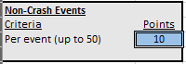**Number of Non-Crash Events** – 3
     1. Each WWD (non-Crash) event = 10 points with 50 pts max
     2. 3 WWD non-crash events * 10 points = 30 points

* 1. 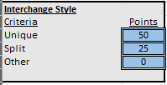**Geometry of Interchange** – Diamond
     1. Diamond = 0 points
  2. 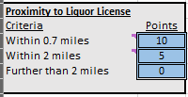**Distance to Store w/ Liquor License** – 0.7 miles
     1. 0.7 miles = 10 points

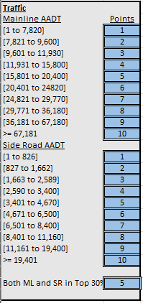

* 1. **Traffic Volumes**
     1. Mainline Volume = 81,000
        1. = 10 points
     2. Sideroad Volume = 15,000
        1. = 9 points
     3. Total points = 10 + 9 = 19 points
  2. **Traffic Bonus Points**
     1. Since both ML and SR AADT volumes are in the top 30%, 5 additional points given.
  3. **Point Total:**
     1. Crashes = 137.5 points
     2. Non-Crash = 30 points
     3. Geometry = 0 Points
     4. Prox. Liquor = 10 Points
     5. Traffic = 19 Points
     6. Bonus Traffic = 5 points
     7. Total – 201.5 (202) points

**Sample Scoring Worksheet**  Interchange:__________________________________

|  |  |
| --- | --- |
| *Category* | *Points* |
| Crash History  No History……………………………………………………………. Add 0 points  0.125 to 0.25 crashes…………………………………………..Add 5 points  0.25 to 0.5 crashes……………………………………………....Add 10 points  0.5 to 0.99 crashes…………………………………….………...Add 15 points  0.99 to 1.5 crashes……………………………………………….Add 20 points  1.5 crashes or more……………………………………………...Add 25 points  Fatal Crash…………………………………………………………...Add 75 points | _____ |
| History of Non-Crash Events  Per Event (first five events)……………………………………Add 10 points | _____ |
| Interchange Geometry  Unique Design………………………………………………………Add 50 points  Folded Diamond with Exit Ramp on Inside……..………Add 50 points  Split Interchange…..………………………………………………Add 25 points  Other Design…………………………………………………………Add 0 points | _____ |
| Proximity to an Address with a Liquor License  Within 0.7 miles………………………………………….........…Add 10 points  Between 0.7 miles and 2.0 miles….........................…Add 5 points  Over 2.0 miles…………………………………………............…Add 0 points | _____ |
| Traffic Volume  Mainline AADT  10th Percentile [1 to 7,820]…………………….…Add 1 point  20th Percentile [7,821 to 9,600] …………….…Add 2 points  30th Percentile [9,601 to 11,930] ……….……Add 3 points  40th Percentile [11,931 to 15,800] ………..…Add 4 points  50th Percentile [15,801 to 20,400] ……..……Add 5 points  60th Percentile [20,401 to 24820] ………...…Add 6 points  70th Percentile [24,821 to 29,770] …………..Add 7 points  80th Percentile [29,771 to 36,180] …………..Add 8 points  90th Percentile [36,181 to 67,180] …………..Add 9 points  100th Percentile (≥ 67,181) …………….………..Add 10 points  Side Road AADT  10th Percentile [1 to 826] ]…….……………….…Add 1 point  20th Percentile [827 to 1,662] ……………….…Add 2 points  30th Percentile [1,663 to 2,589] …………….…Add 3 points  40th Percentile [2,590 to 3,400] …………….…Add 4 points  50th Percentile [3,401 to 4,670] …………….…Add 5 points  60th Percentile [4,671 to 6,500] …………….…Add 6 points  70th Percentile [6,501 to 8,400] …………….…Add 7 points  80th Percentile [8,401 to 11,160] ………..……Add 8 points  90th Percentile [11,161 to 19,400] ……...…..Add 9 points  100th Percentile (≥ 19,401) ……….…………..…Add 10 points  Both Mainline and Side Road in Top 30%..................Add 5 points | _____ |
| **TOTAL SCORE** | _____ |