News Articles:

<https://wcfcourier.com/news/local/two-injured-in-wrong-way-crash-overnight/article_96f3c103-2588-5d18-b8c2-7d141f7dfa39.html>

<https://www.kcrg.com/content/news/Two-hospitalized-following-head-on-crash-on-I-380-564094741.html?ref=741>

Accident Timeline

* Cops head southbound past Cam 10 at 23:58:50
* Cops head northbound past Cam 11 at 23:59:00
* No WWD spotted on Cam 10 between 23:30:00 and 1:00:00
  + The accident must have occurred between these two cameras
    - News article states before the interchange at Raymond, mile marker 85
  + Video footage is too blurry to make out the car in question
    - News article states a white Lexus
* Watched other videos around the same timeline and saw no WWD
* Case Number: 20191143867

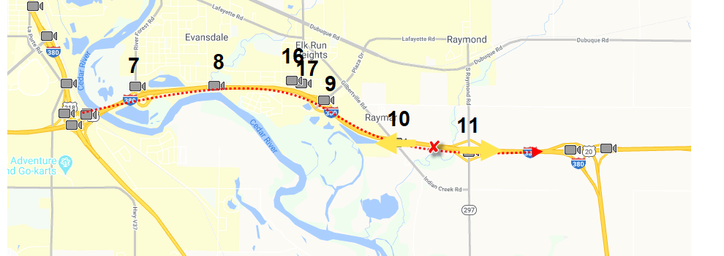

UPDATE: 2/15/2021

After reviewing the accident report, we learn the crash occurred south of mile marker 65. The wrong way driver was heading south in the northbound lane directly after the interchange and hit the pickup truck. The video footage saved does not show the correct area of the crash and the news articles incorrectly reported the incident as occurring at mile marker 85. We know that this cannot be the case after reviewing footage and seeing no instances of a wrong way driver in our camera feed. We speculate that the wrong way driver made a U-turn somewhere between camera 11 and the interchange that the accident took place.